**Aim:** Understanding DevOps Cloud.

**Problem Statement**: Set up a virtual cloud server using AWS EC2 and deploy a basic service on it.

**Objectives:**

1. Understand the role of cloud platforms in DevOps.
2. Create and configure an EC2 instance on AWS.

**Tools Used:** Chrome, AWS

**Concept:**

1. Cloud Computing plays a vital role in the DevOps ecosystem by providing scalable, flexible, and on-demand infrastructure. It eliminates the need for physical hardware and enables rapid provisioning of environments to support development, testing, and deployment.
2. AWS EC2 (Elastic Compute Cloud) is a web service that allows users to rent virtual servers in the cloud. It supports automated deployments, CI/CD pipelines, and efficient application hosting by offering features like elasticity, security, and integration with DevOps tools.
3. Cloud platforms enable Infrastructure-as-Code (IaC), real-time monitoring, and seamless integration with tools such as Jenkins, Docker, and Ansible, which are essential for modern DevOps workflows.

**Steps:**

1. **Login to your AWS Management Console.**

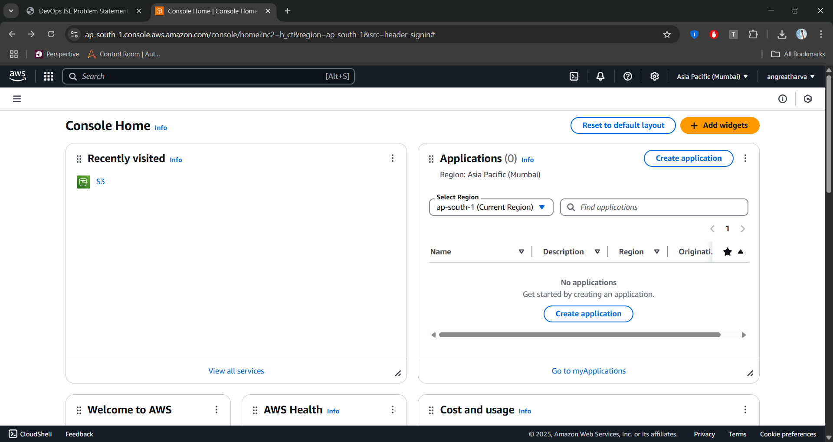

1. **Click on Services ◻ Click on Compute ◻ Select EC2.**

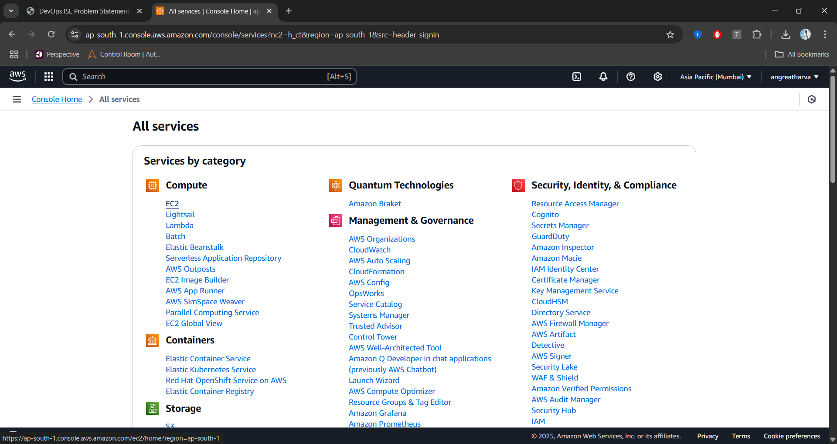

1. **A new window will appear Click on Launch instance.**

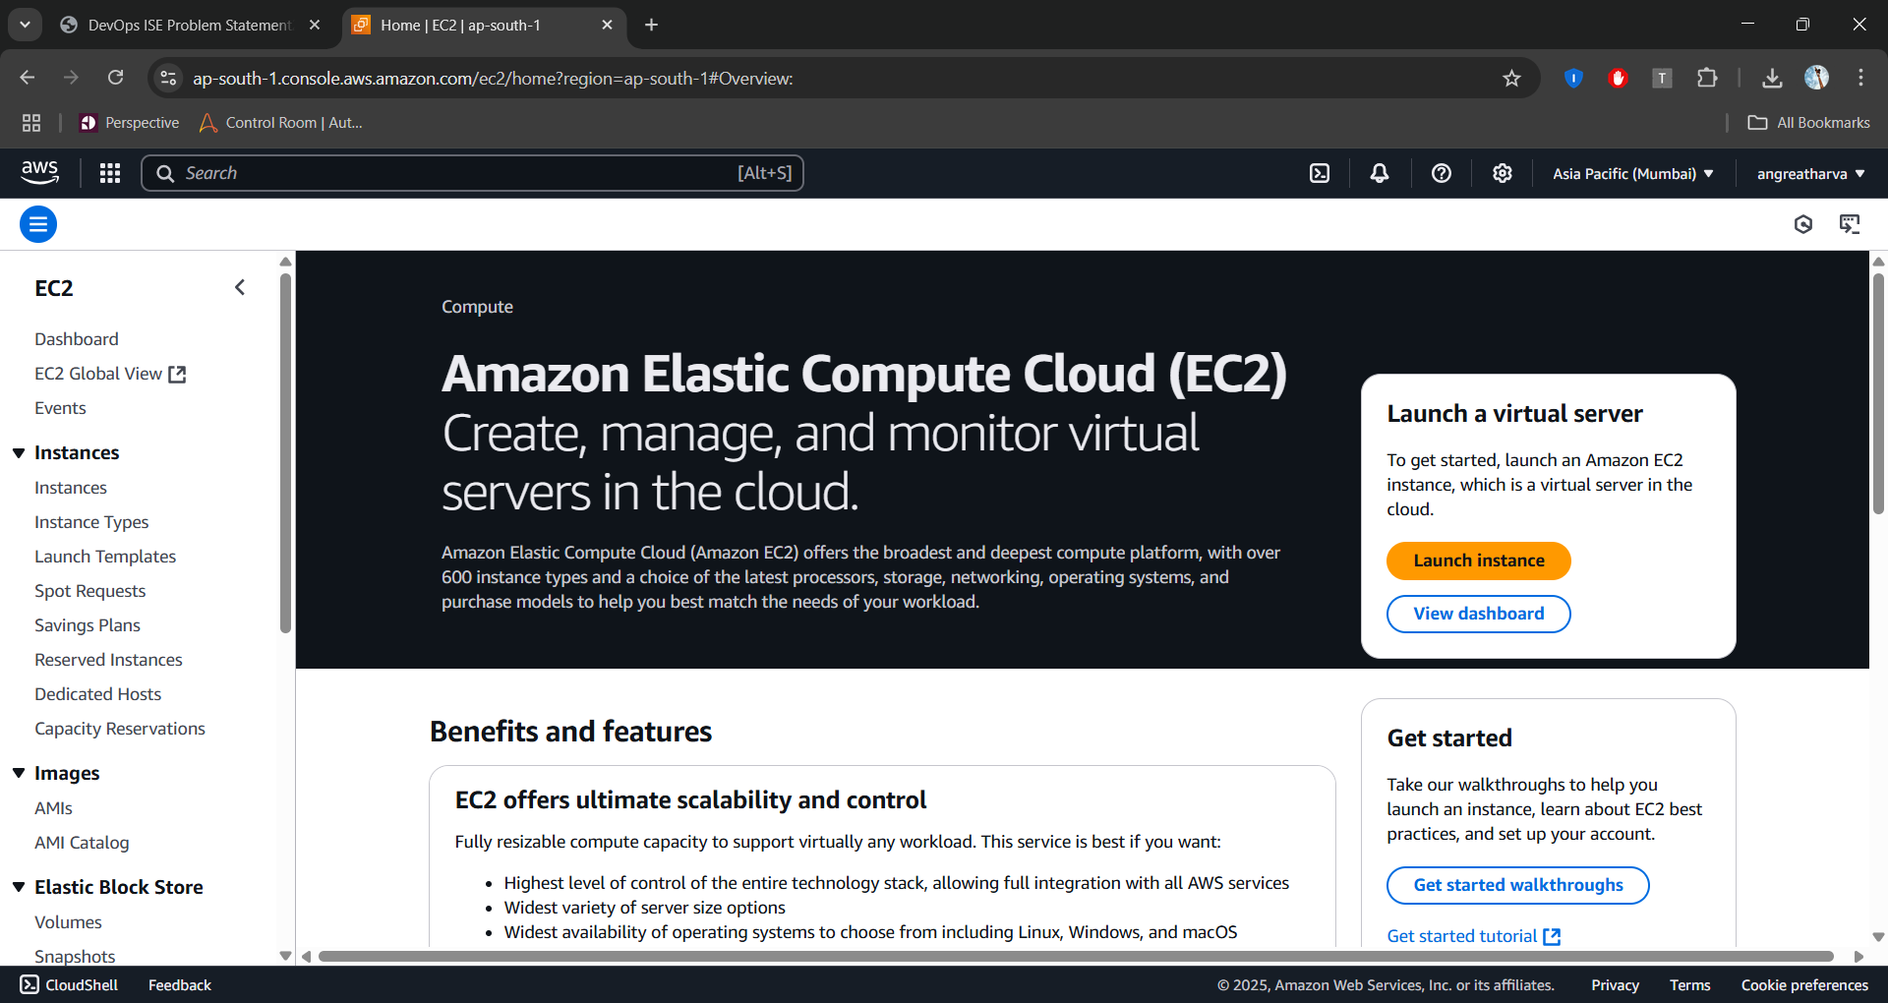

1. **Now a page will appear where you configure your Linux or any OS virtual machine.**

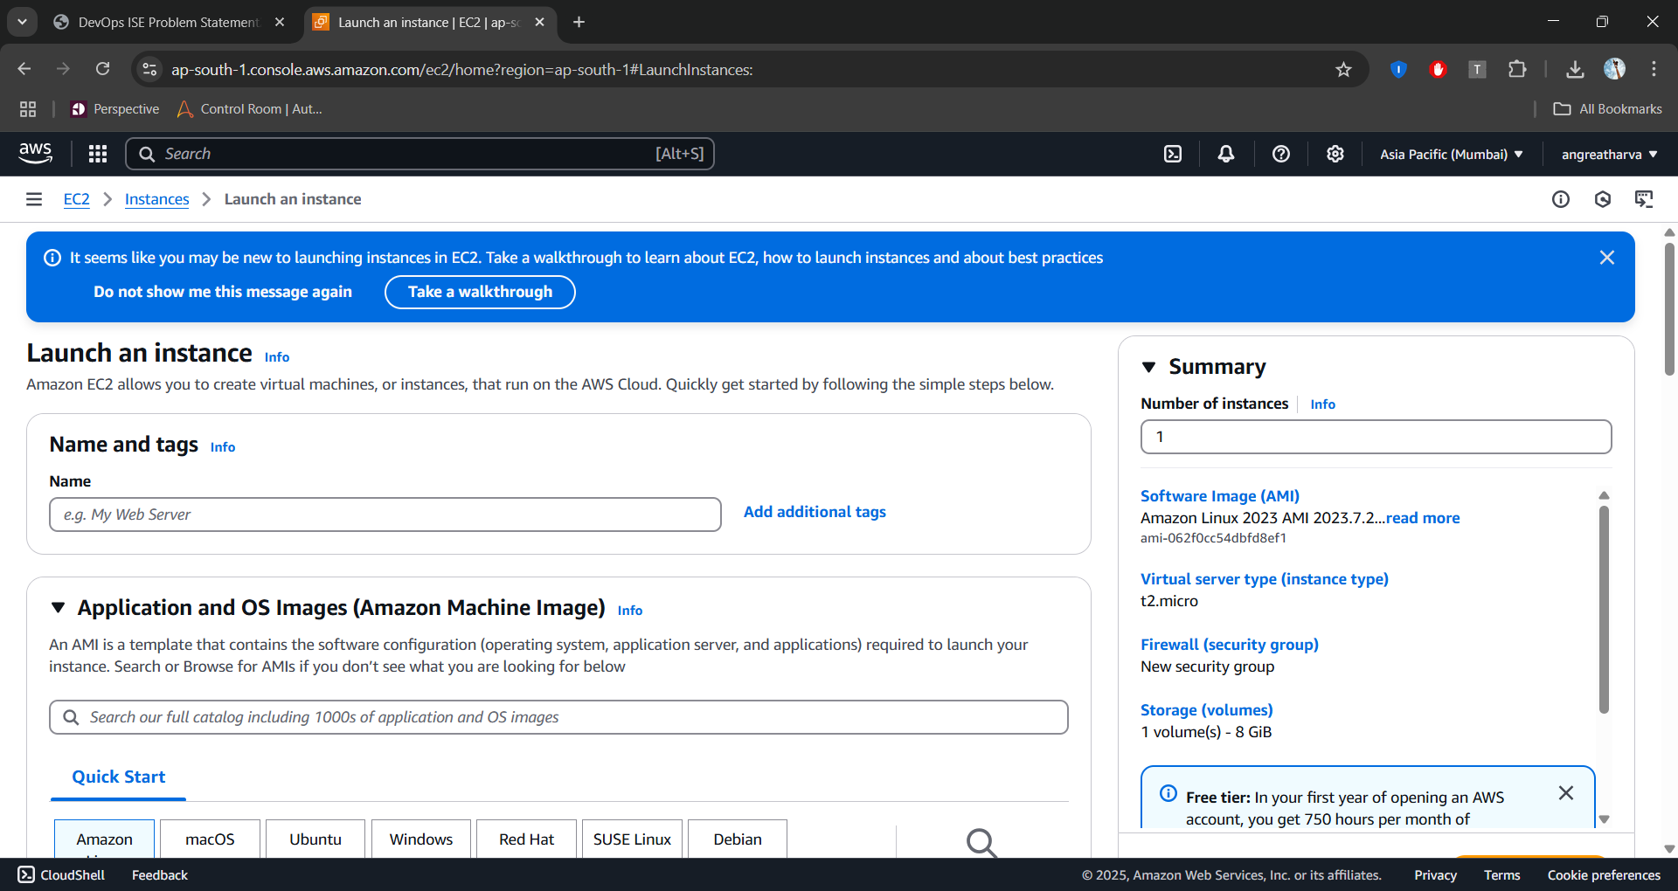

1. **Give name to your machine.**

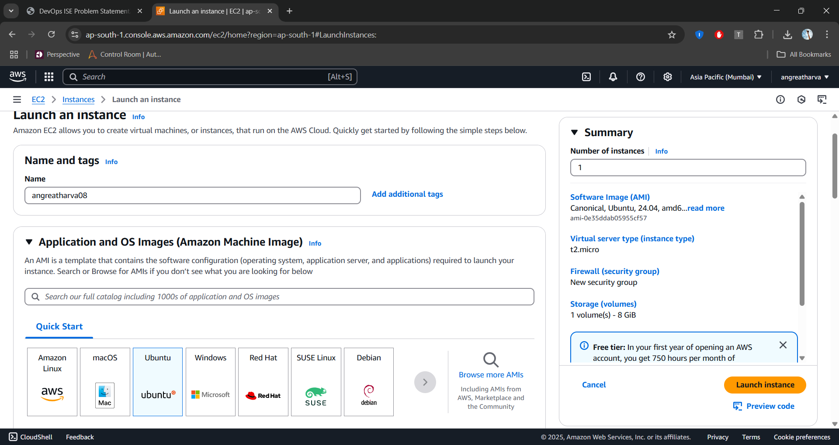

1. **Here you can select your desired OS image. I am selecting ububtu.**



1. 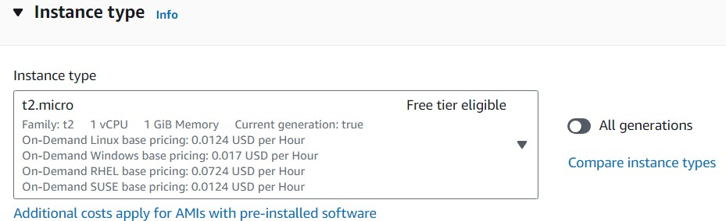**Keep the default configuration of free tier.**
2. 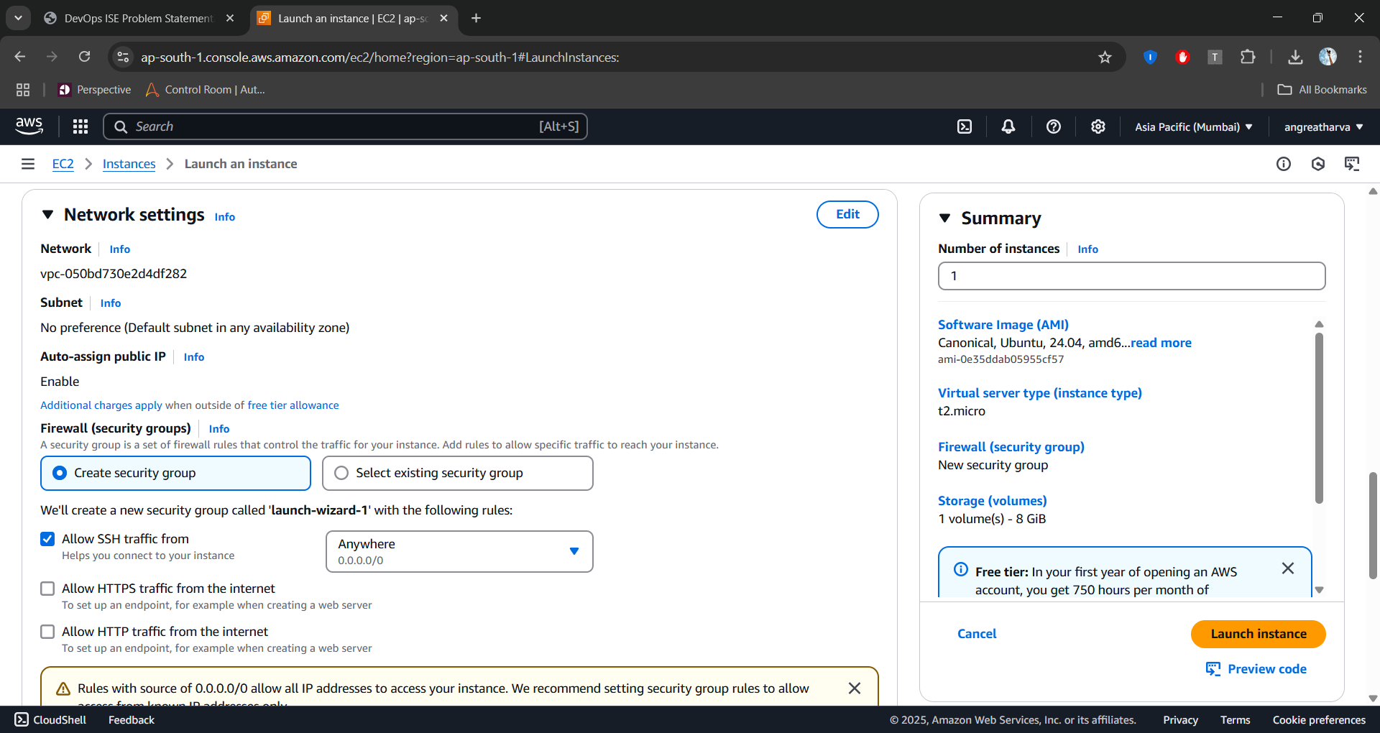**Here is an option of network configuration settings keep default.**
3. 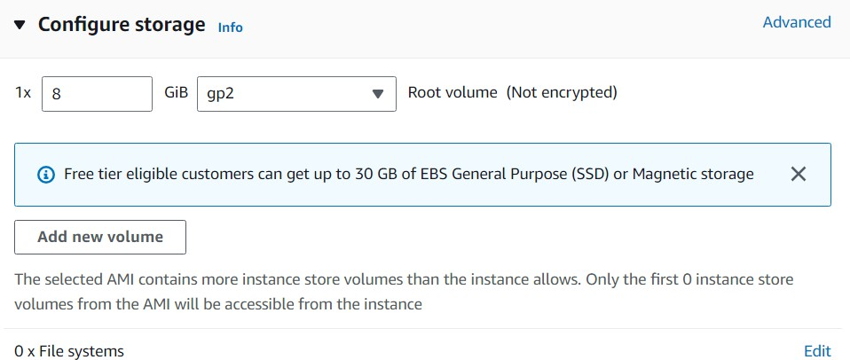**In this section you can configure storage.**
4. **To access you machine form anywhere you need to create “key pair”. It allows you to securely login to your virtual machine.**

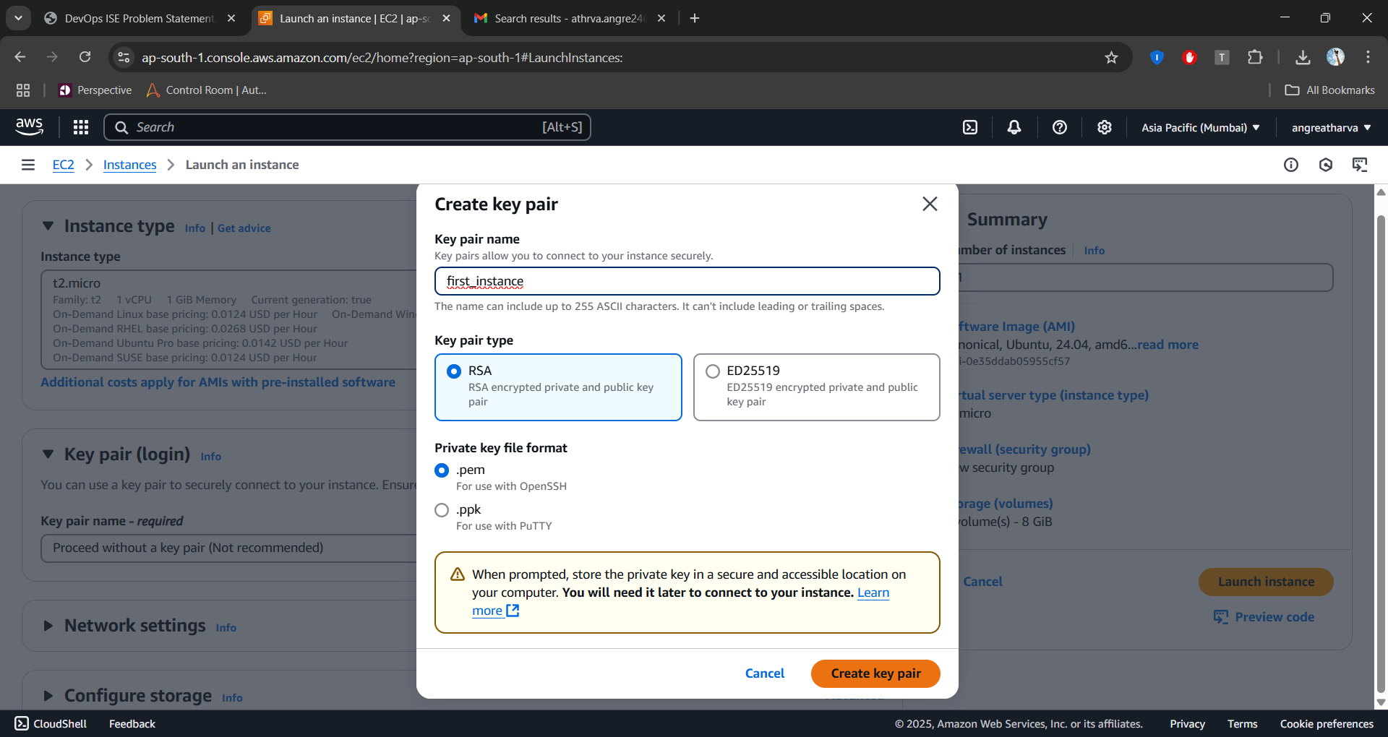

1. **On right panel you can see summary of your machine. After reviewing at bottom Click on Launch instance.**

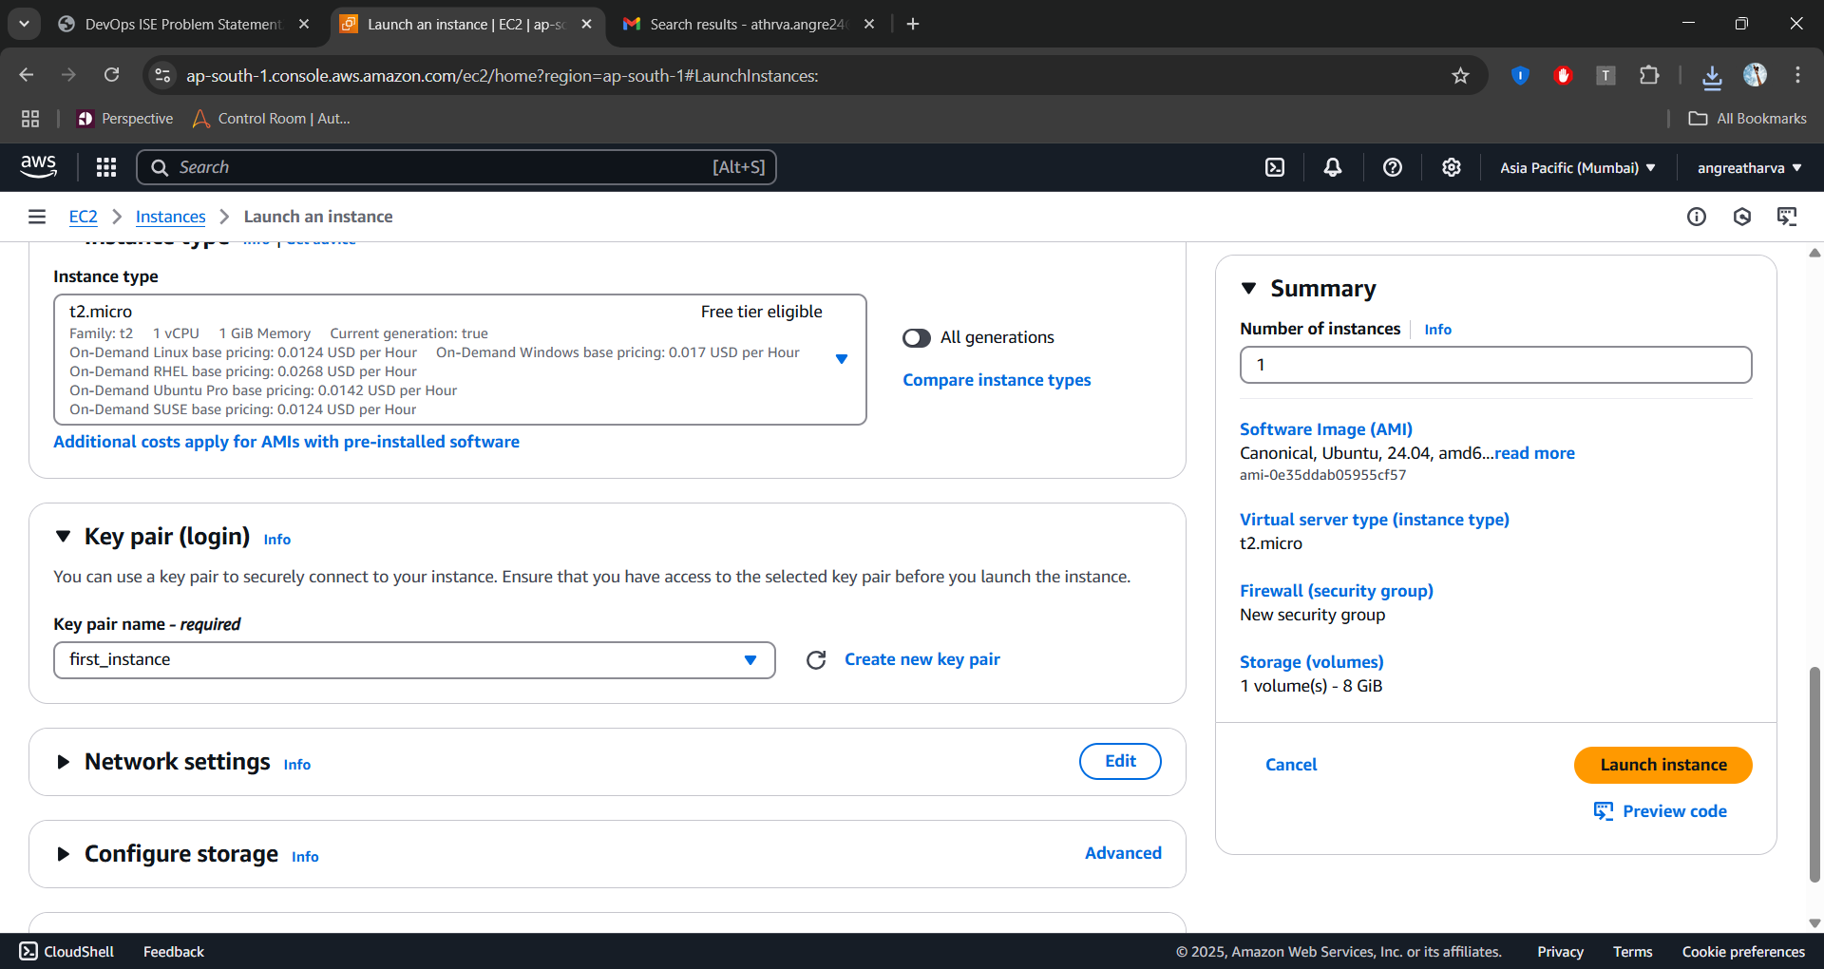

1. **After clicking on Launch instance. An instance will start up and running.**

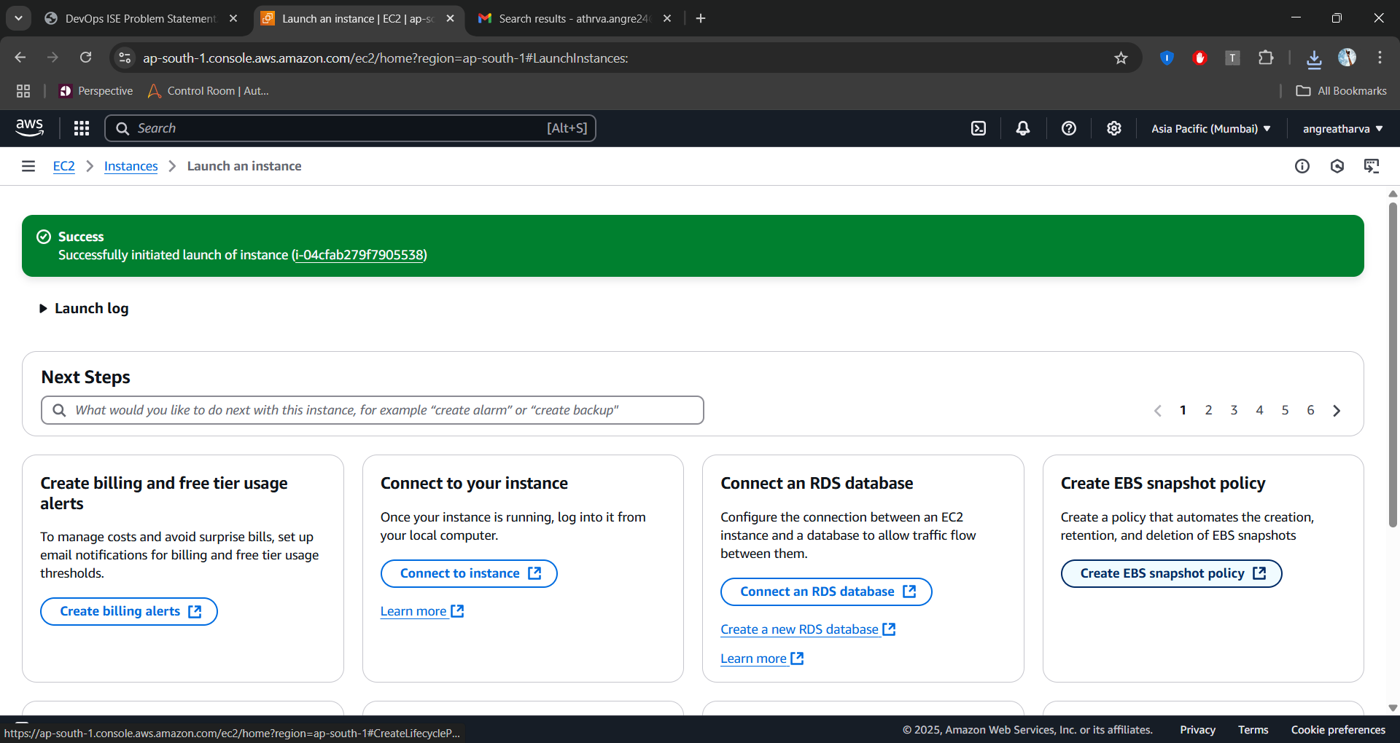

1. **Click on View all instances at bottom right to view your created instance.**

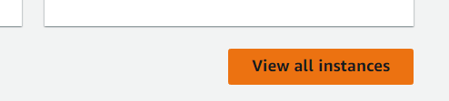

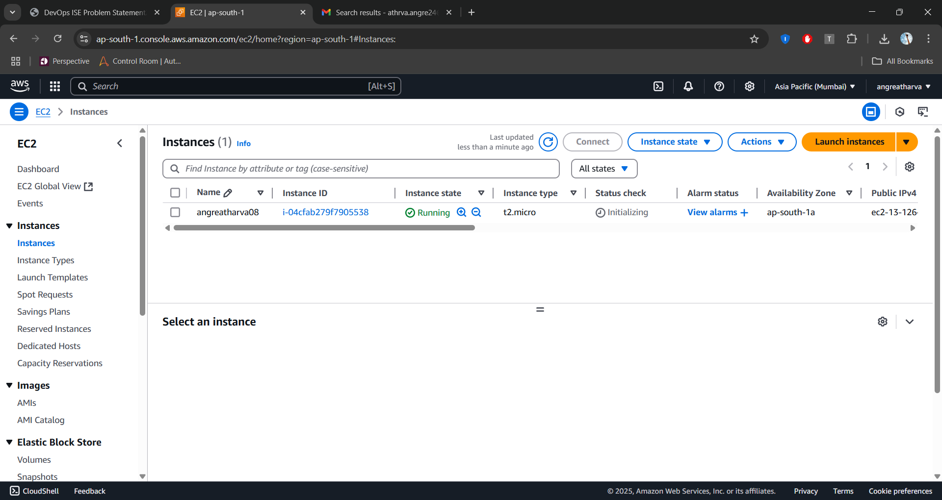

**Observation:**

In this practical, setting up a virtual server using AWS EC2 provides hands-on experience in understanding the role of cloud platforms within the DevOps ecosystem. By following a simple and structured process, users can quickly provision scalable and secure virtual machines, enabling them to host and manage applications efficiently. The integration of services like key pair authentication ensures secure remote access, which is vital in real-world DevOps practices. This exercise highlights how cloud platforms eliminate hardware dependencies, support automated deployments, and contribute to faster development and testing cycles. Overall, AWS EC2 serves as a powerful tool to implement core DevOps principles in a cloud environment.